

Republic of the Philippines DAVAO ORIENTAL STATE UNIVERSITY
“A University of excellence, innovation and inclusion”
Martinez Subdivision, Guang-Guang, Dahican, 8200, City of Mati, Davao Oriental

PROJECT X

Automated Attendance System

Ranel Jr. M. Pagantian
Darvey M. Quimbo
Gella Marie Loginsa

Bachelor of Science in Information Technology 3B

MAY 2025

Introduction
Monitoring student attendance plays a crucial role in educational institutions, but relying on paper-based or manual methods can be inefficient and prone to mistakes or dishonesty. With advancements in technology, there’s now a smarter approach to handling this task.
ClassTrack is a web based and a mobile-based Automated Attendance System (AAS) designed to streamline and secure the attendance process. By incorporating features such as QR code scanning, GPS verification, and One-Time Password (OTP) authentication, ClassTrack ensures the accuracy and legitimacy of attendance records. This modern solution eliminates the drawbacks of traditional methods, reduces opportunities for fraud, and significantly saves time. Through the use of accessible and effective technology, ClassTrack promotes a more reliable and well-organized academic environment.

Purpose
The primary purpose of ClassTrack, a web based and mobile-based Automated Attendance System (AAS), is to replace traditional manual attendance methods with a faster, more accurate, and more secure solution. Manual methods, such as paper-based roll calls, are often time-consuming, prone to errors, and vulnerable to dishonest practices like proxy attendance. ClassTrack addresses these issues by using modern mobile technologies to streamline the attendance process and ensure the reliability of each attendance record.

ClassTrack is designed to simplify attendance tracking through the use of QR code scanning, GPS location tracking, and One-Time Password (OTP) verification. These features work together to verify the identity and presence of each student, making the process more trustworthy and efficient. With its user-friendly interface and mobile accessibility, ClassTrack helps schools and universities create a more organized and accountable learning environment through secure, real-time attendance monitoring.

Objectives
The development of ClassTrack aims to provide an efficient, secure, and reliable solution for automating student attendance in educational institutions. Specifically, the app seeks to:
- Capture real-time and accurate student data, including full name, student ID, course, schedule, and location, ensuring authenticity during the attendance session.
- Record student attendance automatically by tracking QR codes, GPS location, and OTP verification, eliminating the need for manual entry.
- Allow students to view their attendance records for transparency and accountability.
- Generate comprehensive, time-stamped attendance reports that can be accessed by instructors and administrators for analysis.

Scope
The ClassTrack system is specifically designed for educational environments, where courses, students, and instructors are predefined and managed by an administrator. Students are able to log in to the system using their credentials but cannot sign up, as account creation is managed and controlled by administrators.
The system uses QR code scanning, GPS location tracking, and One-Time Password (OTP) verification for authentication and attendance recording, eliminating the need for manual attendance-taking. ClassTrack does not support biometric scanning (e.g., facial recognition or fingerprints), focusing on the combination of these technologies for user verification and accurate attendance tracking.

Definitions & Acronyms

Attendance Tracking | The process of recording and monitoring student presence during class sessions to ensure accurate records are maintained.
ClassTrack | A web Based and mobile-based Automated Attendance System
(AAS) designed to simplify and secure the attendance tracking process in educational
institutions by utilizing QR codes, GPS tracking, and OTP verification.

Authentication | The process of verifying the identity of a user (in this case, the student) before allowing them to mark attendance.
GPS | GPS: Global Positioning System
GPS Location Tracking | A technology used to determine the geographic location of a student’s device during attendance to verify their physical presence in the designated location.
One-Time Password (OTP) | A time-sensitive, single-use password generated for each attendance session to authenticate students and confirm their presence.
QR | Quick Response (Code)
QR Code | A two-dimensional barcode that is scanned by a
mobile device to quickly verify the identity of the student during attendance marking.

Requirements

Functional Requirements

Attendance Feature

    - The system shall record roll call attendance. [R01]
    - The system shall support location-based (GPS) verification to confirm student attendance. [R03]
    - The system shall validate the user against the QR. [R04]
    - The system shall enforce OTP authentication to enhance security. [R05]
    - Scan students' QR codes to record attendance in real time. [R09.7]
    - Students shall be able to view their attendance records. [R10.1]
    - Students shall NOT be allowed to modify or delete attendance records.
[R10.2]

User Roles

    - The system shall support three primary roles: [R08]
      - Administrator [R08.1]
      - Instructors [R08.2] ○ Students [R08.3]

Device Registration
    - Only registered devices shall be allowed in the system. [R02]
    - Only authorized users shall be able to use a registered phone, tablet, or computer to identify students. [R09.1]
    - Phones used for attendance tracking shall be registered and linked to a specific authorized user. [R09.2]
    - Each instructor may have multiple registered devices. [R09.3]
      - But a device can only be registered to 1 instructor. [R09.3.1]

    - The system shall provide functionality to locate a lost registered lecturer's phone. [R09.4]

Student Features

    - The system shall enable Administrator to capture student pictures using a registered device and store: [R07]
      - A passport-style photo [R07.1]
      - The student’s name and university ID [R07.2]
      - The photo as a file and the student’s details in the database
[R07.3]
    - Only authorized users shall assign schedules and enroll students.
[R09.6]
    - Remove students from a course if they drop out. [R09.8]
    - Access course-related data, including student enrollment, attendance records, and course details. [R09.9]

Administration

    - Authorized users shall be able to create, read, update, and delete (CRUD) courses. [R09.5]

Report Generation

    - The system shall generate the following reports: [R06]
      - Attendance [R06.1]
      - List of Students [R06.2]
      - List of Lecturers [R06.3]
      - List of Courses [R06.4]
      - Students’ enrolment per course [R06.5]

Non-Functional Requirements

System Quality and Reliability
    - The database shall be hosted on a cloud server. [R11]
    - System feature access shall be restricted to authenticated users via a secure API. [R12]
    - Testing shall be conducted at multiple levels: [R13]
      - User Acceptance Testing (UAT): Validate system compliance with client expectations. [R13.1]
      - System Testing: Ensure seamless integration of all system components. [R13.2]
      - Unit Testing: Verify the correct functionality of individual components. [R13.3]

Documentation & Development Standards
    - The system’s formal documentation shall include: [R14]
      - System Requirements [R14.1]
      - System Design [R14.2]
      - User Acceptance Test (UAT) [R14.3]
    - The documentation and code should be persisted in Version Management tool like GIT to control versioning, team sharing and safe keeping. [R15]
    - Your GIT repositories should be made available to me. [R166] 4. The system’s high-level documentation shall include: [R17]
      - A High-level Use Case Diagram to representing system interactions and workflows. [R17.1]
      - A High-level UML Diagram is used to illustrate relationships between system entities. [R17.2]
      - A Conceptual Diagram providing a high-level representation of system architecture, key components, and their interactions.

[R17.3]

      - Proof of Conceptual model Review [R17.4]
      - Project Plan (a breakdown matric of what is to be done by when)
[R17.5]
      - With plan and actual columns [R17.6]
- Detailed design documentation shall include: [R18]
  - Component Diagram [R18.1]
  - Class Diagram showing classes and methods [R18.2]
  - Activity diagrams [R18.3]
  - At least 1 detailed sequence diagram [R18.4]
  - Evidence of a Detailed Design review [R18.5]
- Implementation [R19]
  - Clear well-structured code [R19.1]
  - Code should be well commented with standard headers [R19.2]
  - Evidence of the daily team standups [R19.3]
  - Evidence of Code Reviews [R19.4]
  - Final output [R19.5]

Use Case Diagram

Conceptual Model

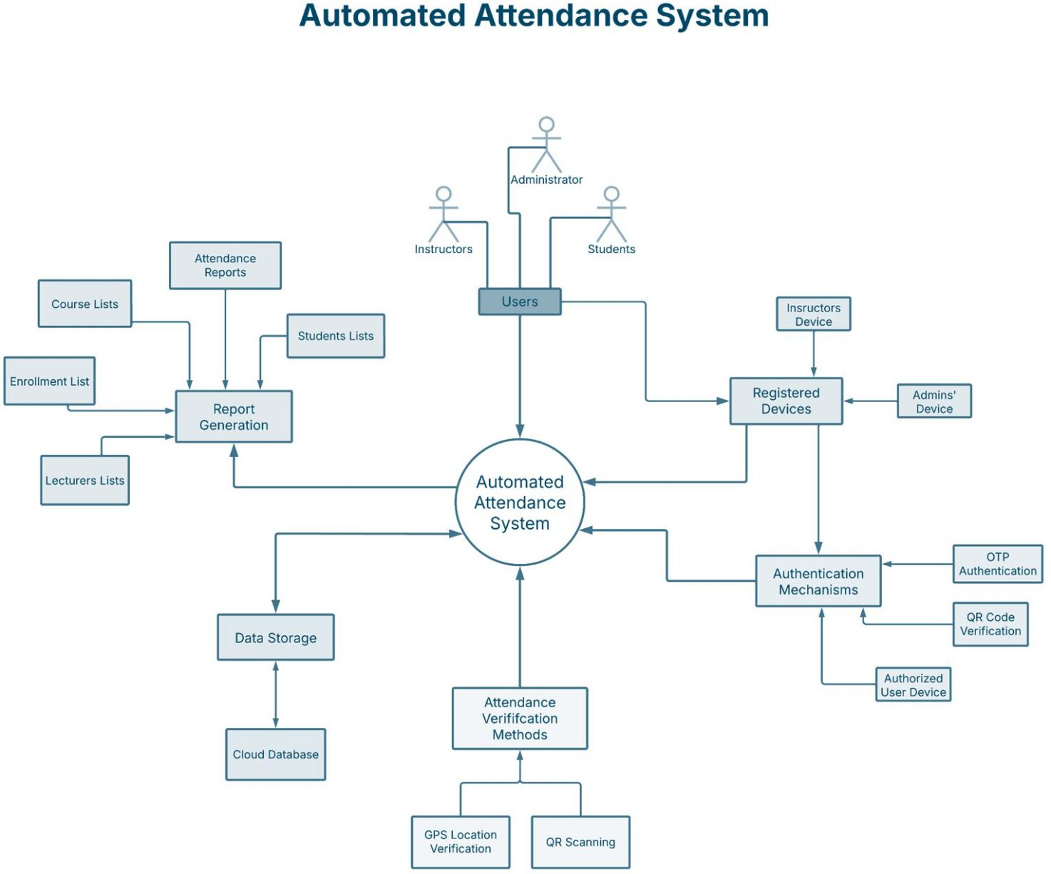

Use Case #1: Device Registration

Scenario: Instructor Device Registration and Usage

- An instructor logs into the system and navigates to the Device Registration section.
- They register a new phone by providing necessary details.
- The system links the phone to the instructor and stores the device ID.
- The instructor uses the phone to track student attendance.
- If the instructor loses the phone, they request the system to locate it.
- The system provides the last known location or other recovery options.
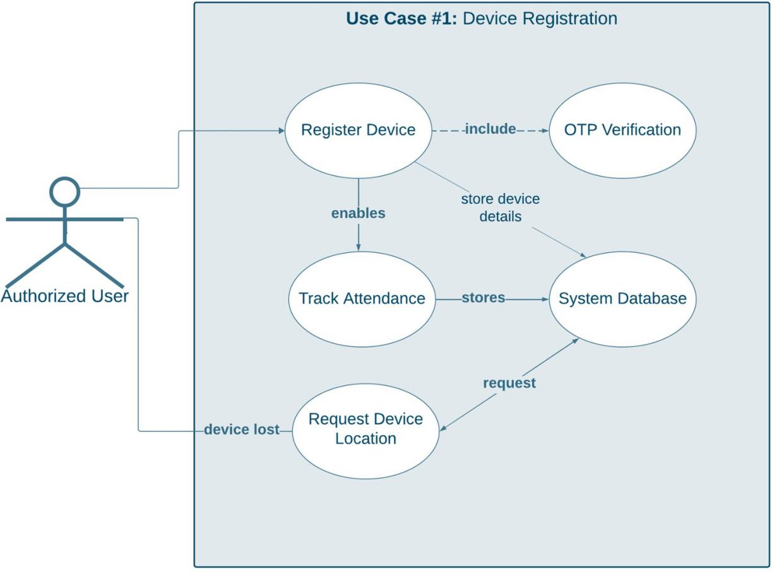

Use Case #2: Course Enrollment and Management

Scenario: Managing Courses and Student Enrollment

- The administrator logs into the system and navigates to the Course Management section.

- They create, update, or delete a course as needed. (R09.5)
- The administrator assigns a schedule and enrolls students in the course. (R09.6)
- If a student drops out, the administrator removes them from the course. (R09.8)
- The system updates student enrollment records.
- The administrator captures a passport-style photo of a student, along with their name and university ID. (R07, R07.1, R07.2, R07.3)
- The system stores the photo and details in the database for future identification.
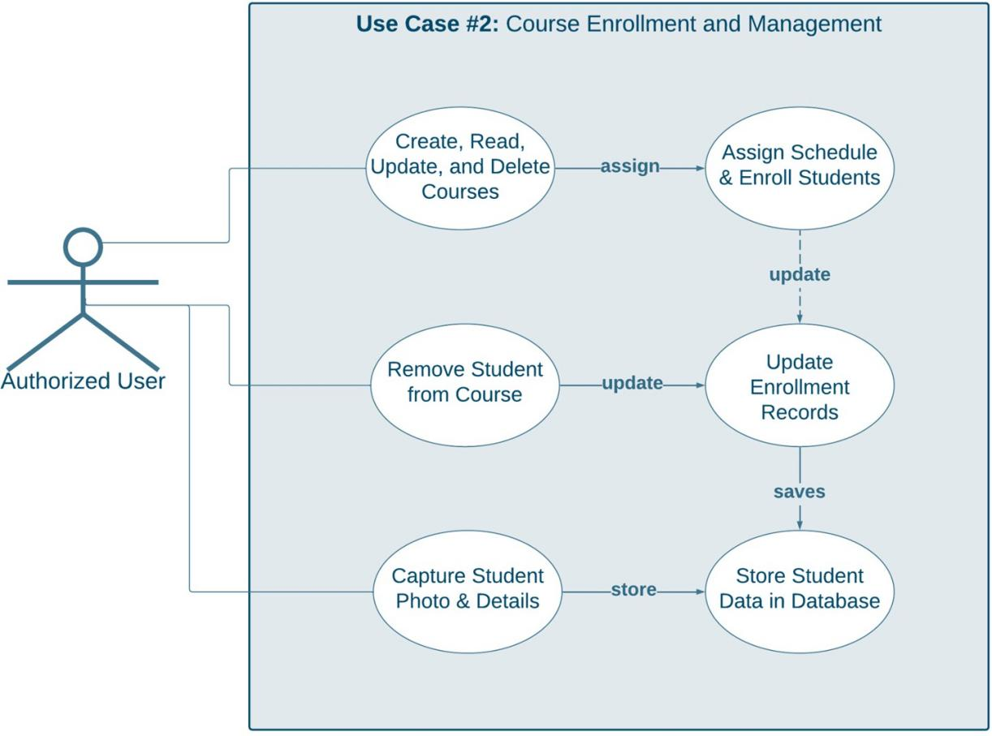

Use Case #3: Record Roll Call Attendance

Scenario: Instructor Recording Attendance
- The instructor logs into the system using a registered device.
- They navigate to the Attendance Tracking section.

- The instructor selects a course and the corresponding student list appears.
- The student displays a QR code generated on their device. (R04)
- The instructor scans the QR code to validate the student's identity.
- The system prompts for GPS verification to confirm the student's location. (R03)
- For additional security, the system enforces OTP authentication before finalizing attendance. (R05)
- Once verified, the system records the attendance.

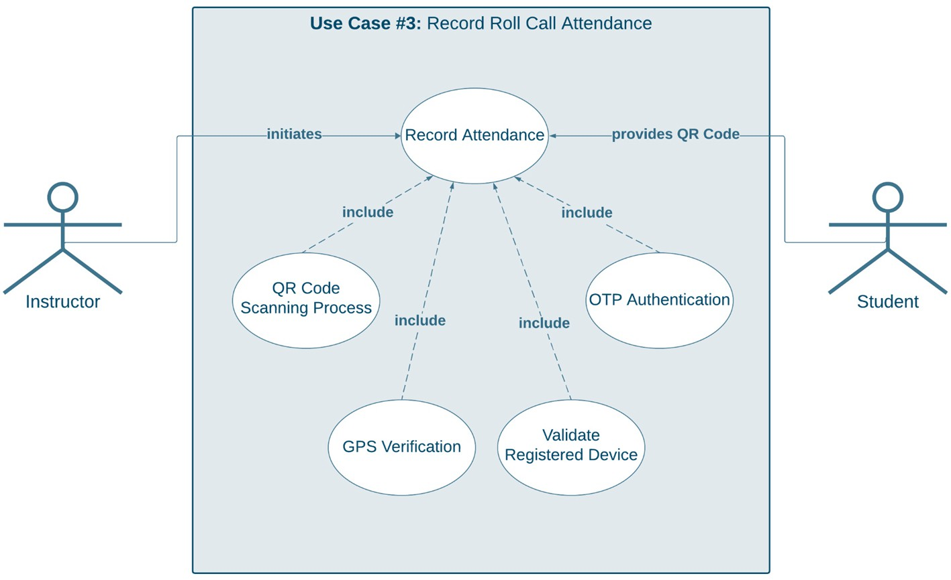

Case #4: Generate Attendance Report

Scenario: Administrator Generating Reports
- The administrator logs into the system and navigates to the Reports section.
- They select the type of report to generate:
  - Attendance records (R06.1)

  - List of students (R06.2)
  - List of lecturers (R06.3)
  - List of courses (R06.4)
  - Student enrollment per course (R06.5)
- The system retrieves the requested data from the database.
- The administrator views, downloads, or prints the report for record- keeping.
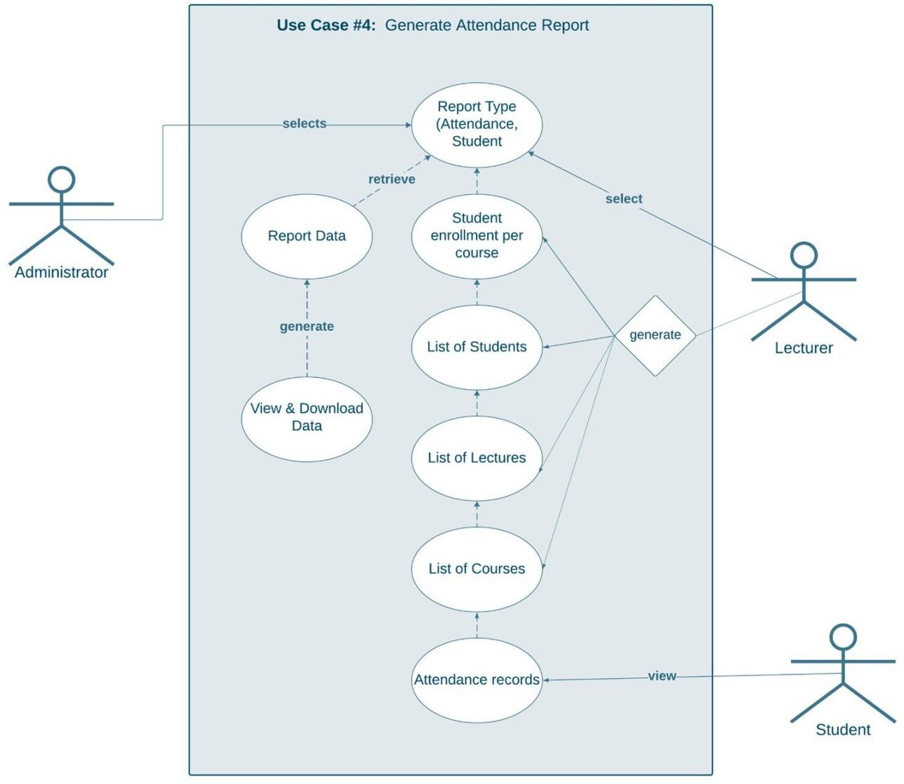

Use Case #5: Student Interface

Scenario: Student Viewing Attendance Records
- The student logs into the system and navigates to the Attendance Records section.

- The system displays their attendance history for verification. (R010.1)
- The student reviews their attendance details but cannot modify or delete any records. (R010.2)
- The student logs out after verifying their records.
